# Manual of Plugin:List Products

--Power by RQQ.

### Add Products to web page:

1. Click ‘Add’

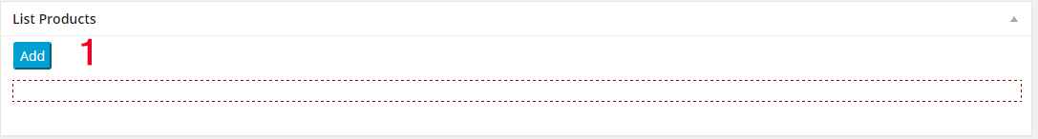

**Picture A**

1. Name a table column name. Leave blank to hide this column. In the last slide down option,choose a column,and the URL will add to this column.
2. Choose the products
3. Fill the link in this input field. Leave blank if it do not has a link. Double click to use the default value.
4. Save it.
5. Use this red text in the post.Copy it and paste it.(See picture C). See the result in Picture D

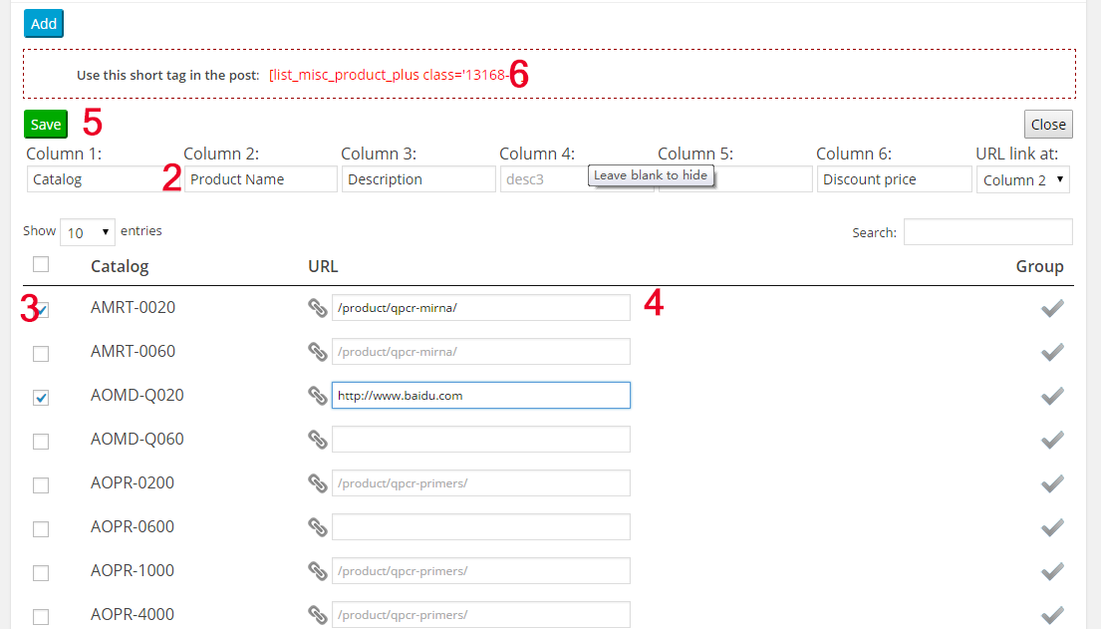

**Picture B**

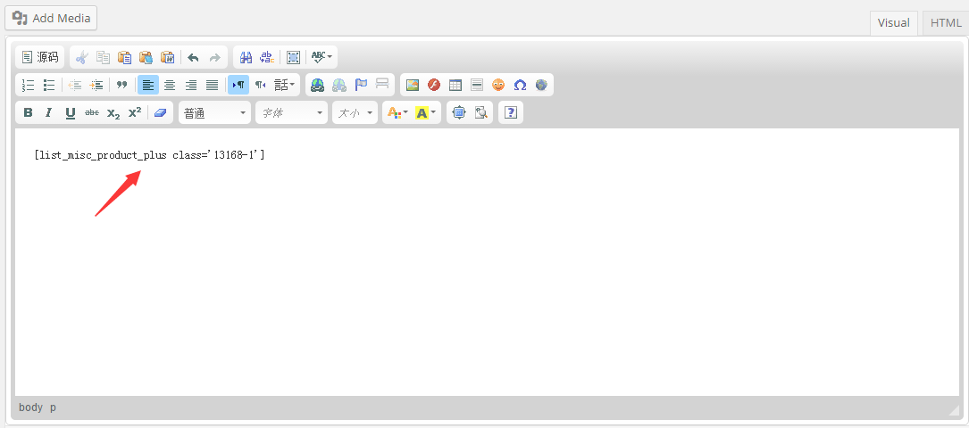

**Picture C**

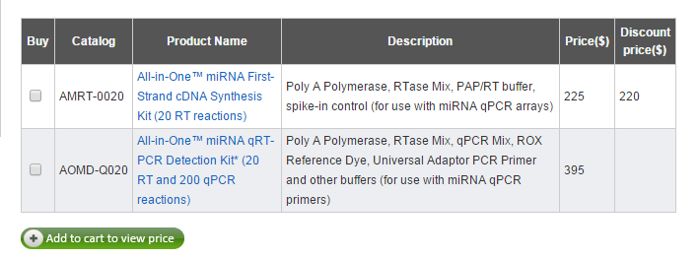

**Picture D**

1. You can combine the rows to 1 row. Click the ‘Group’ button (7), Click the “Line merge” button (8), then they are grouping (9) .
2. And see the result in Picture G.

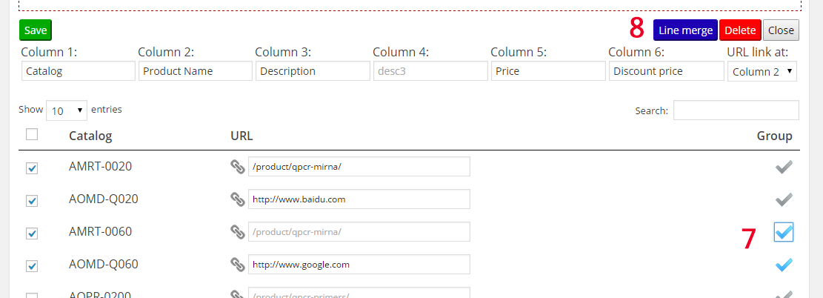

**Picture E**

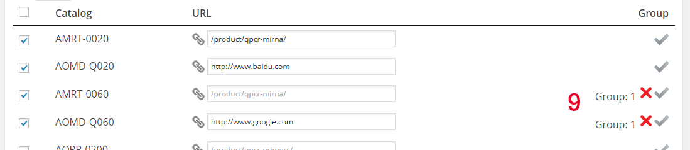

**Picture F**

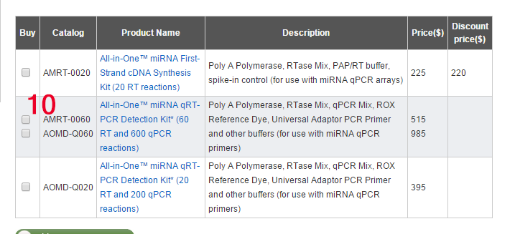

**Picture G**

### View the shortcode which is already exists:

11.Choose the button Update:... , then you can edit the table.

